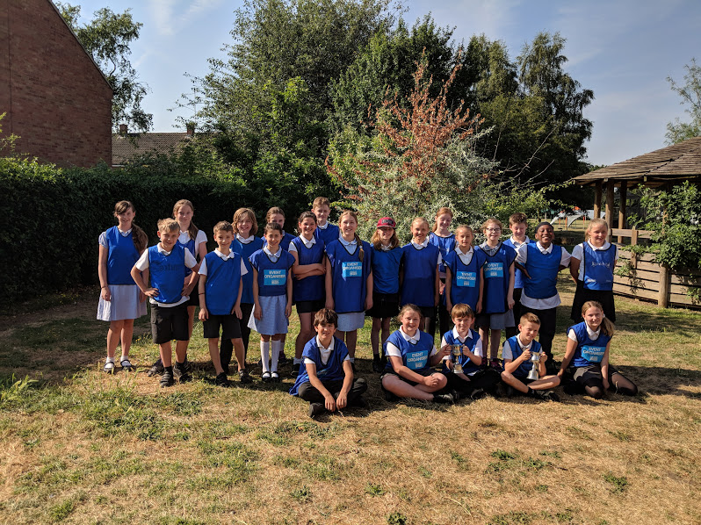

Our Summer Sports’ leaders did a fantastic job organising Sports day, encouraging their team, marking score cards and leading the warm up for their teams. Well done!

