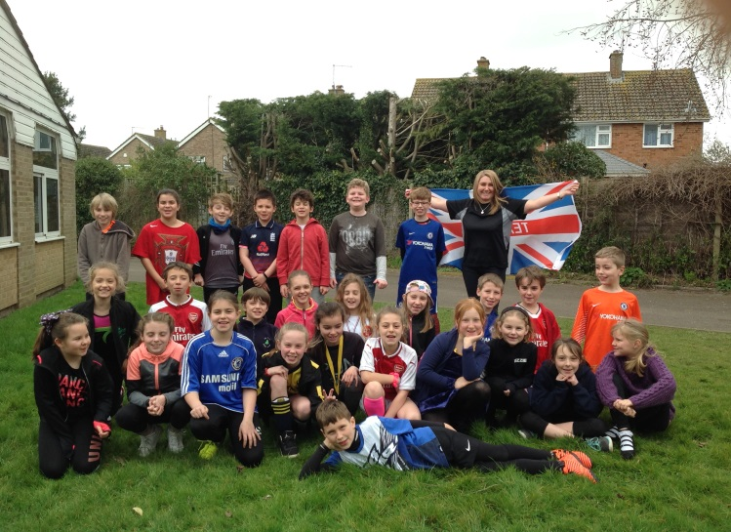

Sport Relief- 2018

Sadly, our tennis taster day was cancelled due to the snow. We will rearrange this for the summer term.
Each class also had their Judo grading this week. This was very exciting! All children that took part in the 15 week program have earned their yellow belt. A massive thanks to Mr. Hutton for his amazing Judo lessons!
Even Siva and Felipe got involved in Sport relief week. 170 children and staff enjoyed the champion chicken burger served with ‘runner beans’ and athletes apple crumble to finish. After all the exercise we had this week- what a well-earned treat. Thank you for always preparing delicious, nutritious dinners!

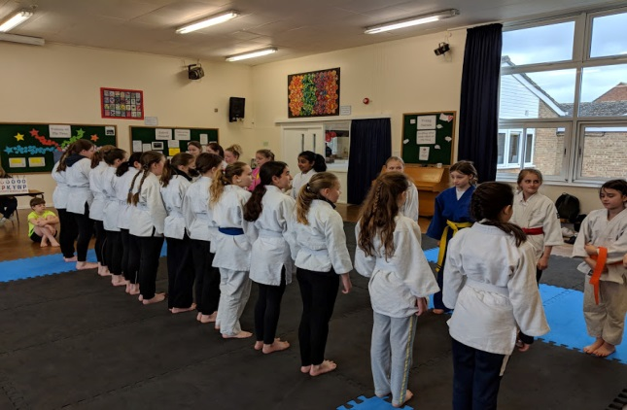
Each class dressed as their favourite sportsperson or wore their comfiest PE gear for a £1 donation. Here is Chestnut class rocking the look! We managed to raise £241.73. Stan in Year 6 did a sponsored bounce and raised an amazing £72! Well done Stan for being incredibly self/values smart. Well done Fir Tree!



All children were encouraged to increase their steps this week. Each child was given a record card to record how many laps of the school field they did at lunchtime. For every 3 laps, children were given a gem. The gem pots are looking very full now!
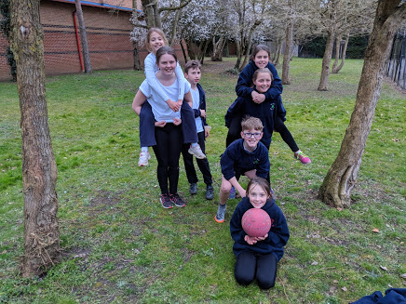
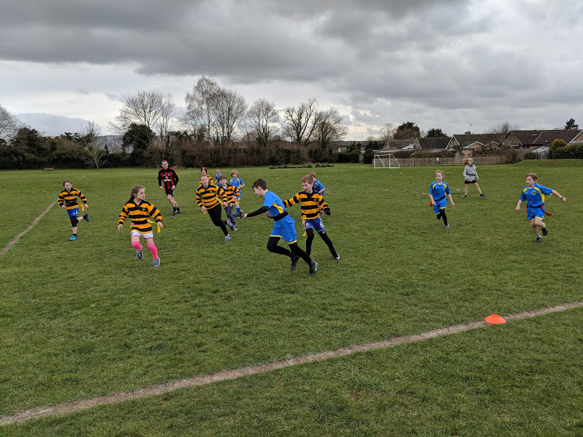
Tournaments and matches.
Our netballers played in a tournament at Wallingford school. We won a match, drew two matches and lost a match. We saw some fabulous shooting and defending by the team.
Our hockey team came second in the partnership tournament at Wallingford school on Monday. They are through to the county finals- we wish them luck- go Fir tree!
Some of our pupils enjoyed a tag rugby match versus Brightwell school after school on Friday. We won the match 12-8- well done team! We had a second match where we split the two schools up. This match was a draw. We provided tea and cake for a donation to Sport relief and raised £12. It was a fab way to end our sporty week!

